**Computer Networks 1**

**Lab 1**

**Network Devices**

Student Name: Le Huy Hoang

Student No.: 1652212

**I. Objectives:**

* Get to know basic network devices
* Understand functions of network devices
* Able to connect different network devices together to form a simple network

**II. Content**

**1. Get to know network devices:**

* Network Interface Card (NIC)
* Cables
* Hub
* Switches
* Routers
* Access Points
* Modems

**2. Understanding functions of network devices**

**a. Network Interface Card (NIC)**

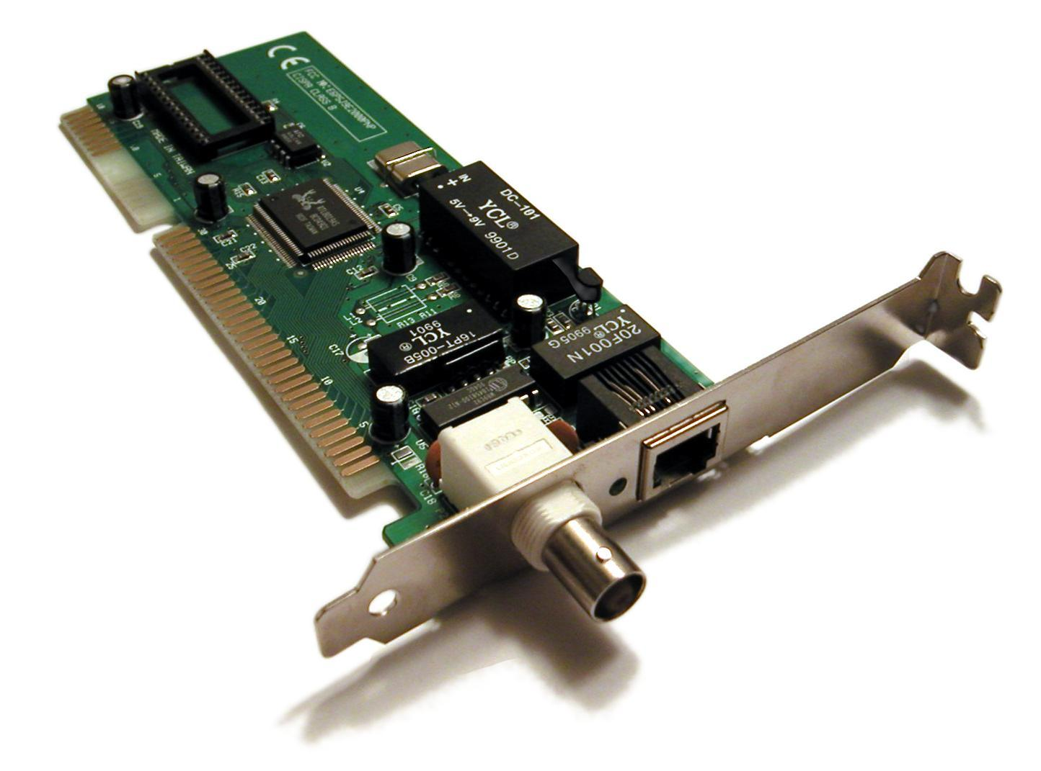

NIC functions: provides a computer with a dedicated, full-time connection to a network by implementing the [physical layer](https://searchnetworking.techtarget.com/definition/physical-layer) circuitry necessary for communicating with a [data link layer](https://searchnetworking.techtarget.com/definition/Data-Link-layer) standard, such as [Ethernet](https://searchnetworking.techtarget.com/definition/Ethernet) or [Wi-Fi](https://searchmobilecomputing.techtarget.com/definition/Wi-Fi)

Code of NIC processors: ________________________________________________

Check NIC of a computer, what is its MAC address? Unique identifier assigned to NIC for communicating with Datalink layer.

Cable to connect NIC to a network:

Type: Ethernet cable

Standard: CAT5, CAT6

**b. Hubs**

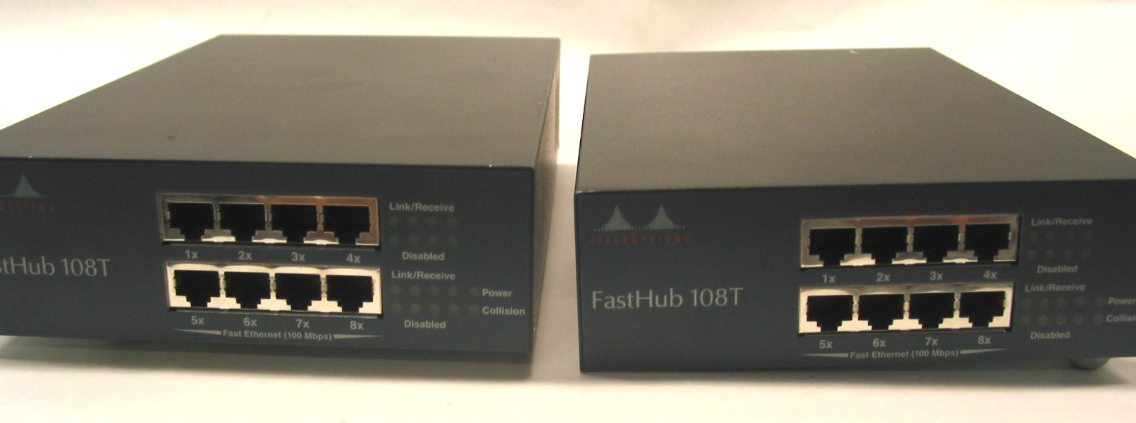

Roles of hub in a network: Connect computers belong to a network

Main characteristics: operate at Layer 1. When a host sends a packet to another host inside the network, Hub merely forwards all bit of that packet to every other hosts.

Weaknesses of hub: Few connections established, less security

Hub ports: RJ45

**c. Switches**

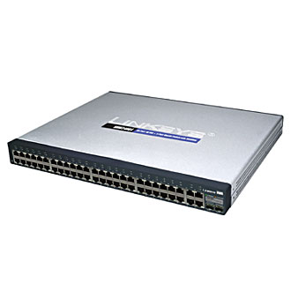 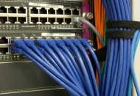

Roles of switches in a network: Similar with Hub but more advanced

Main characteristics of switches: operate at 2nd layer, send packet to appropriate host

Differences between hubs and switches: more connections allowed, rather than send bits to every other hosts, Switch sends packet to exactly host.

Weaknesses of switches: expensive, errors occurring are difficult to trace

Switch ports: RJ45

**d. Routers**

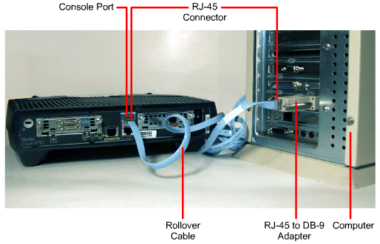

Roles of routers in a network: route the packet based on its destination embedded

Main characteristics of routers:

Differences between routers and switches: Switch operates at 2nd layer, while it is 3rd layer for Router

Router ports: RJ45

**d. Access Points**

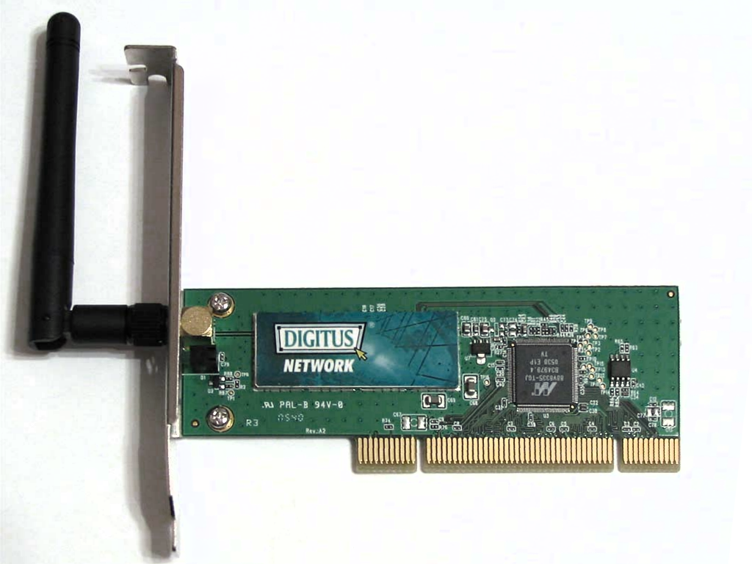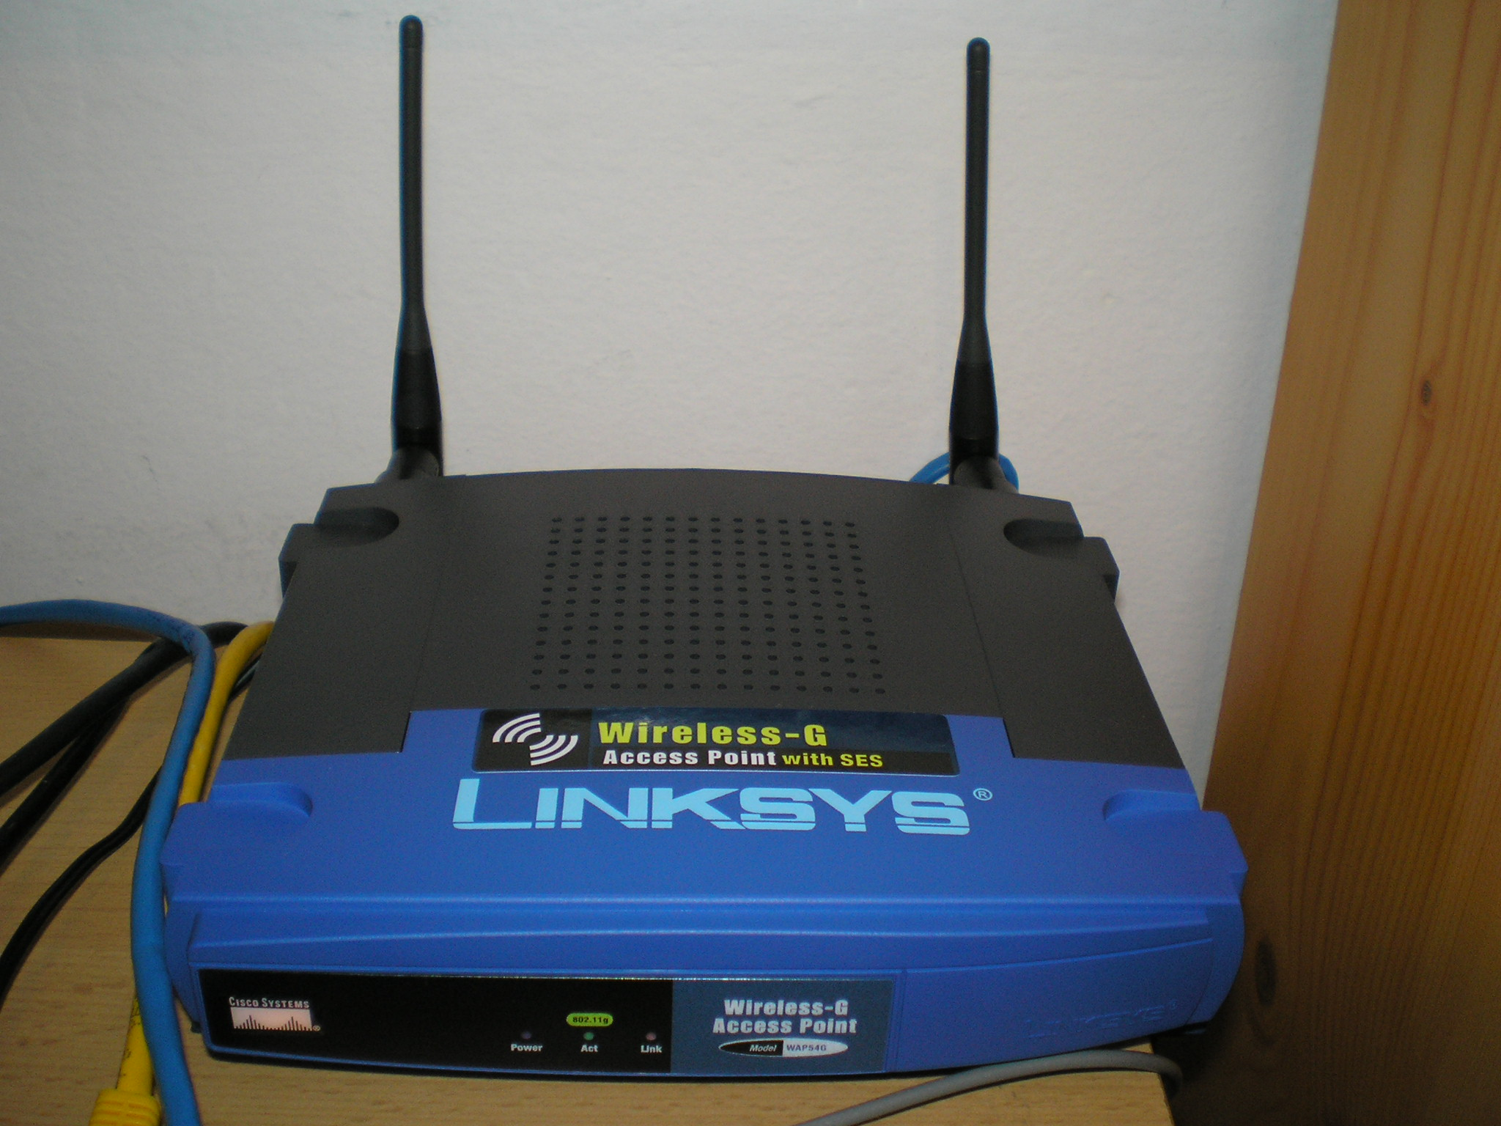

Roles of access points: make it available for devices to connect to Internet wirelessly, create WLAN

Main characteristics of access points:

Access point’s interfaces:

Compare access point and other networking devices mentioned above:

**e. Modem**

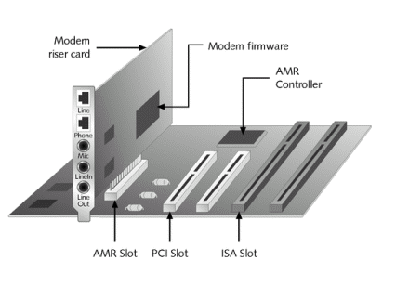 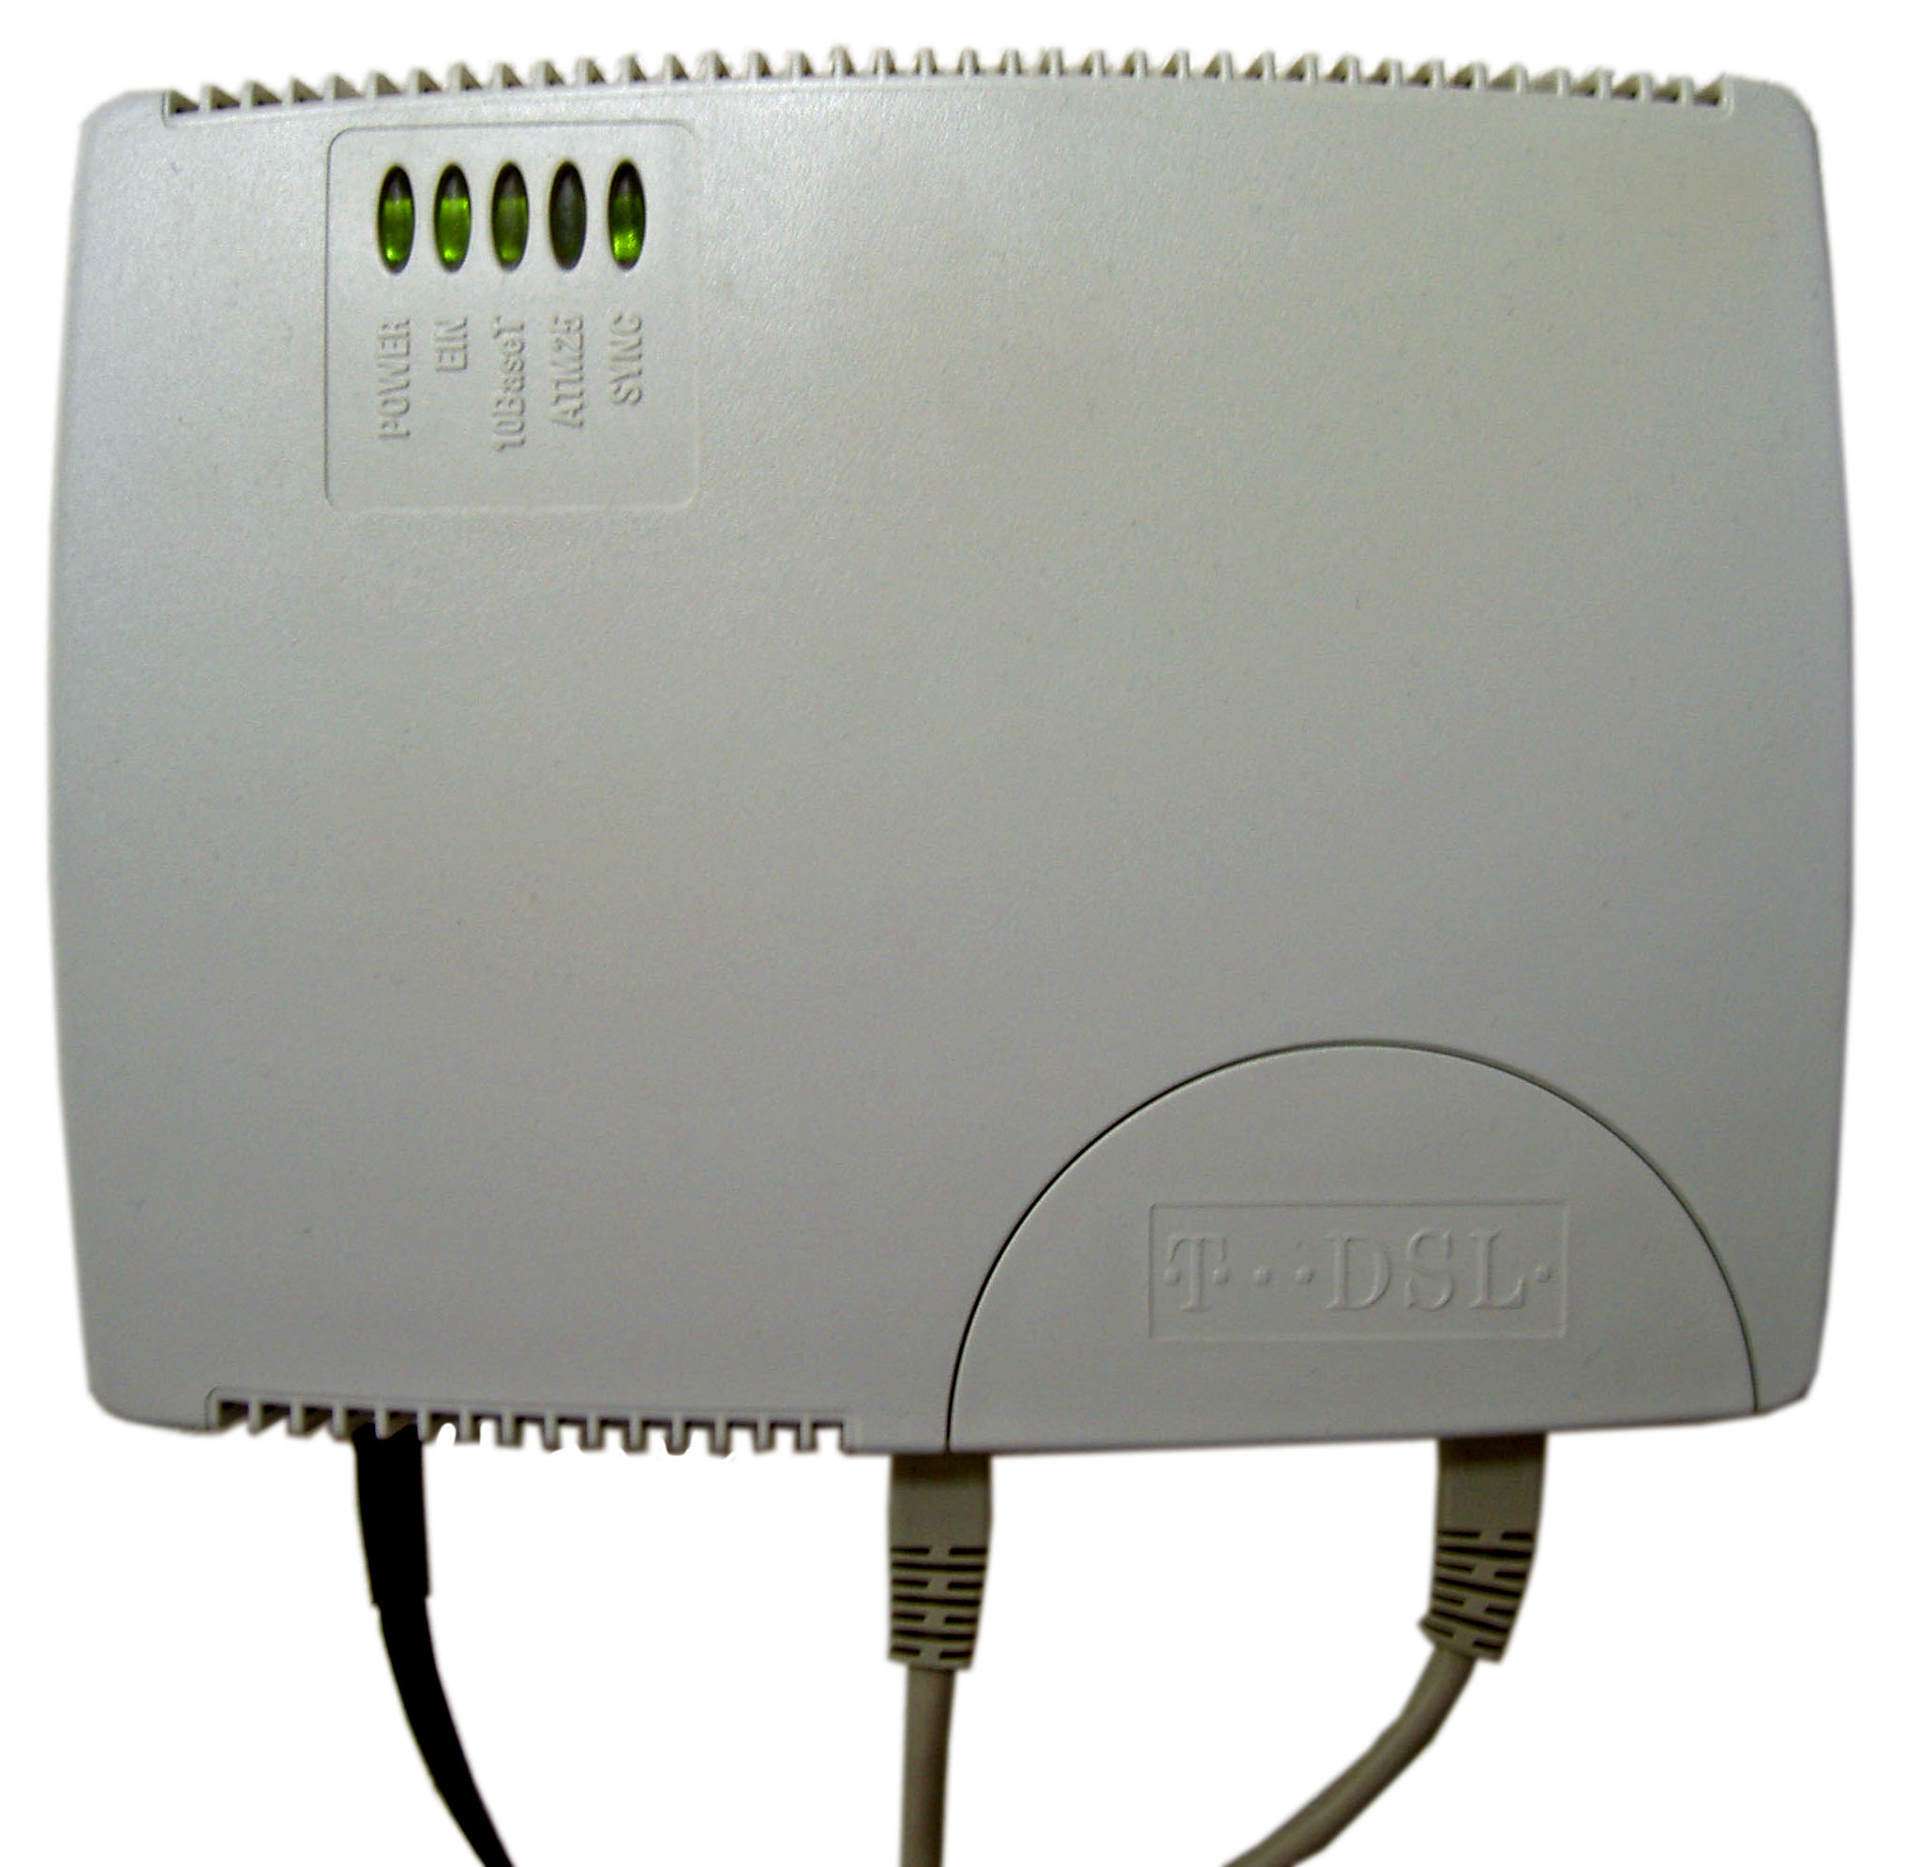 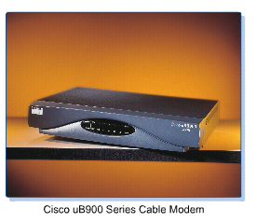

Differentiate:

* Dial-up modem: phone line plug directly to modem, no frequency splitter
* ADSL Modem: phone line plug directly to modem, have frequency splitter
* Cable Modem: have frequency splitter component that splits analog signal and Internet signal

For each type of modem describe its roles and characteristics:

**3. Connecting network devices:**

**Identify the type of network cable can be used for below network connections:**

a) Computer and hub : Ethernet cable

b) Computer and switch: Ethernet cable

c) Computer and router: Ethernet cable

d) Computer hub and hub: Ethernet cable

e) Hub and switch: Ethernet cable

f) Hub and router: Ethernet cable

g) Switch and switch: Ethernet cable

h) Switch and router: Ethernet cable

k) Router and router: Ethernet cable